Contestant Number: ____________________
Time: ___________________
Rank: _______________



College Accounting
(105)

NATIONAL 2024

CONCEPT KNOWLEDGE:

Multiple Choice (10 @ 2 points each) ________________ (20 points)
APPLICATION KNOWLEDGE:
Short Answer ________________ (32 points)
Problem 1 - Depreciation ________________ (40 points)
Problem 2 – Equity Transactions ________________ (48 points)

TOTAL POINTS ________________ (140 points)

Test Time: 90 minutes
GENERAL GUIDELINES:
Failure to adhere to any of the following rules will result in disqualification:
- Member must hand in this test booklet and all printouts if any. Failure to do so will result in disqualification.
- No equipment, supplies, or materials other than those specified for this event are allowed in the testing area. No previous BPA tests and/or sample tests (handwritten, photocopied, or keyed) are allowed in the testing area.
- Electronic devices will be monitored according to ACT standards.
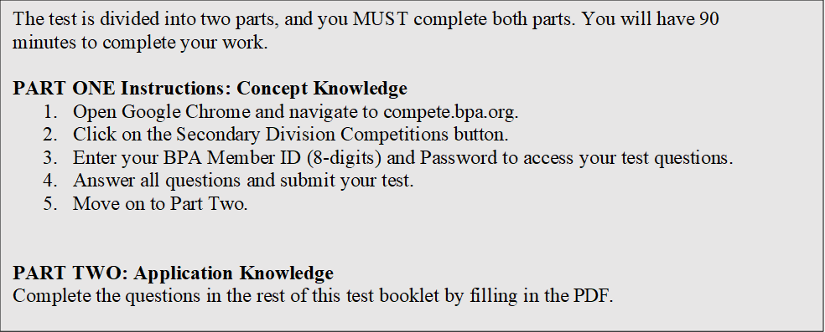
EXAM GUIDELINES:
You have been hired as a Financial Assistant and will be keeping the accounting records for Digital Solutions, located at 700 Morse Road, Suite 201, Columbus, Ohio 43214. Digital Solutions provides accounting and other financial services for clients. You will complete jobs for Digital Solutions’ own accounting records, as well as for clients.

You will have 90 minutes to complete your work. The test is divided into two parts: concept knowledge and application knowledge.

Your name and/or school name should not appear on any work you submit for grading. Write your Member ID in the provided space. Staple all pages in order before you turn in your test.

Assumptions to make when taking this assessment:
- Round all calculations to two decimals at the final step.
- Round all percentages to one decimal place.
- Use 360 days for interest calculations.

Short Answer
- Mansfield Inc. is selling $200,000, 8%, 10-year bonds that pay interest semi-annually. Calculate the selling price under each of the independent scenarios, and indicate if the bond will sell at face value, premium, or discount.
Quoted selling price | Selling Price | Face Value, Premium or Discount
98.5
100
101.7

- On December 31, 2023, Bedford Corp. sold warehouse shelving for $545,000; the shelving had originally cost $900,000. Cash was paid by the buyer of the shelving. Accumulated Depreciation on the shelving, updated to the date of disposal, was $450,000. What is the journal entry to record the disposal of the asset?

- Hurst Technologies invested $58,000 to acquire $58,000 face value, 12%, five-year corporate bonds on December 31, 2023. The bonds pay interest semi-annually on June 30 and December 31 every year until maturity. What is the journal entry that Hurst will make on December 31, 2024?

- Colleyville Inc.’s Accounts Receivable has a balance of $4,000, and the Allowance for Bad Debts has a credit balance of $400.
What is the net realizable value of Accounts Receivable?

- Lewisville, Inc. bought a new cash register for $7,500. Lewisville plans to use the cash register for 4 years and then sell it for $600.
What is the cash register's depreciable cost?

- On January 1, 2024 Frisco Company issued $250,000, 10%, 10-year bonds that pay interest semi-annually on June 30 and December 31 at 102. Frisco uses the straight-line method of amortization. Prepare the appropriate journal entries on the date of issuance and on the first interest payment.
Jan. 1
June 30

Problem 1: Depreciation Problems (40 Points)
Burleson Machines purchased a new piece of equipment for $78,000. Burleson estimates that they will use the equipment for five years, and then sell the equipment for $12,000. The equipment was purchased on January 12, 2024. Calculate Burleson’s annual depreciation under each method, assuming Burleson uses the mid-month convention.
Straight-line Method | Depreciation Expense | Book Value
December 31, 2024
December 31, 2025
December 31, 2026
December 31, 2027
December 31, 2028
Double-Declining Balance
December 31, 2024
December 31, 2025
December 31, 2026
December 31, 2027
December 31, 2028

Problem 2: Equity Transactions (48 Points)
On their December 31, 2023 balance sheet, Dallas Corp. reported 50,000 shares of $2 par value outstanding common stock at $125,000. Prepare the appropriate journal entries for 2024.
On February 15, Dallas issued an additional 10,000 shares of common stock when the price was $2.2 a share.
Date | Account | Debit | Credit

On March 1, Dallas purchased 5,000 shares of its own common stock when the price was $23 a share.
Date | Account | Debit | Credit

On May 1, Dallas declares $88,000 of dividends to be paid on May 31 to shareholders of record on May 15. Prepare all appropriate entries with the appropriate dates.
Date | Account | Debit | Credit

Dallas sold 2,500 shares of its own stock previously acquired on June 20, when the price was $27 a share.
Date | Account | Debit | Credit

Dallas issued 200 shares of 6%, $100 par value preferred stock on August 10 at par.
Date | Account | Debit | Credit

On October 5, Dallas sold 200 shares of its own stock previously acquired, when the price was $24 a share.
Date | Account | Debit | Credit

On December 20, the Board of Directors declares $71,900 of dividends payable on January 20 to shareholders of record as of January 5.
Date | Account | Debit | Credit

